Part A: Practical Tasks

Task 1: Explore the default policy

Security policy view:
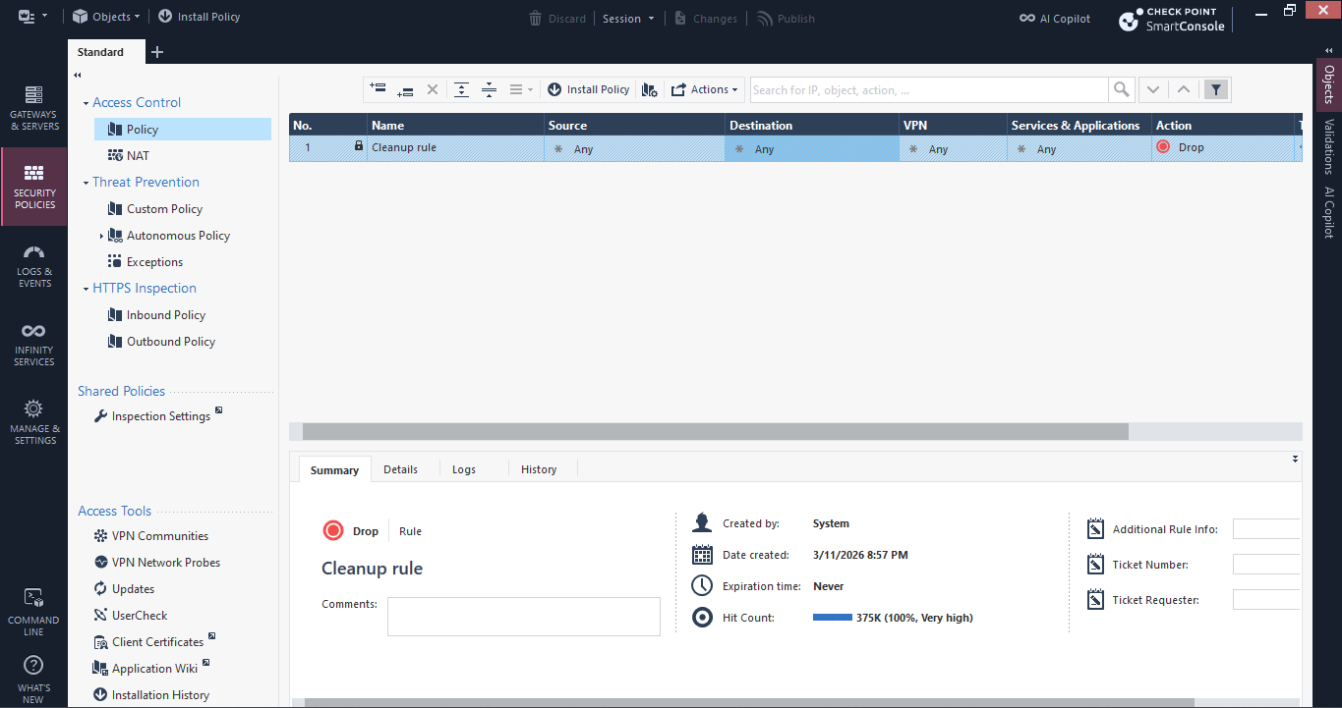

Name: Cleanup rule
Source: * Any
Destination: * Any
Services & Applications: * Any
Action: Drop
Track: - None
Install on: * Policy Targets
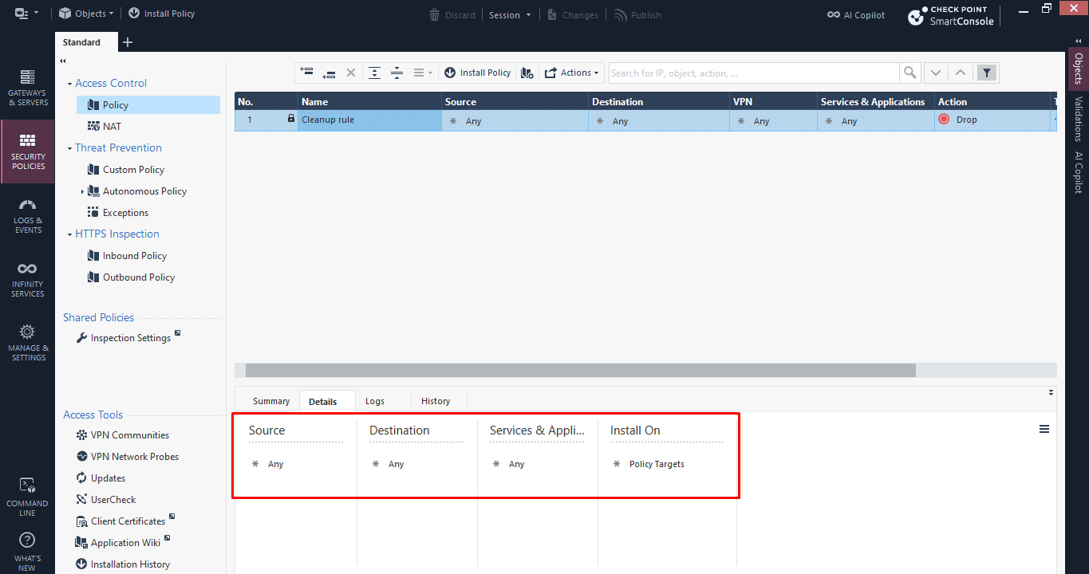

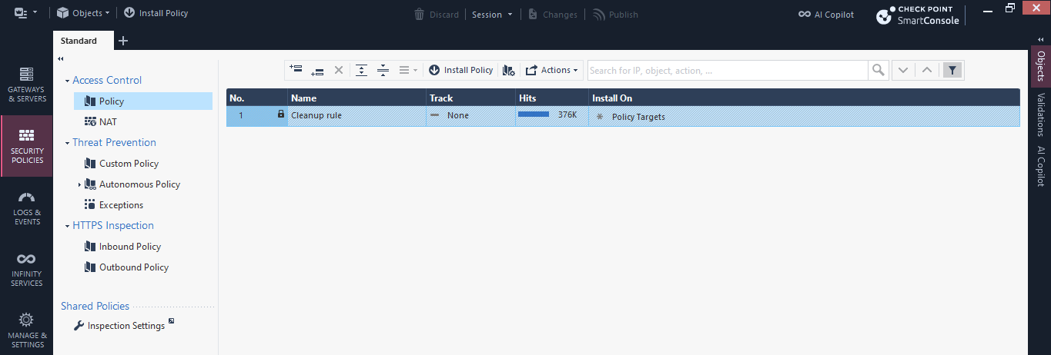

Global Properties
Categories:
VPN
Firewall
Log and Alert
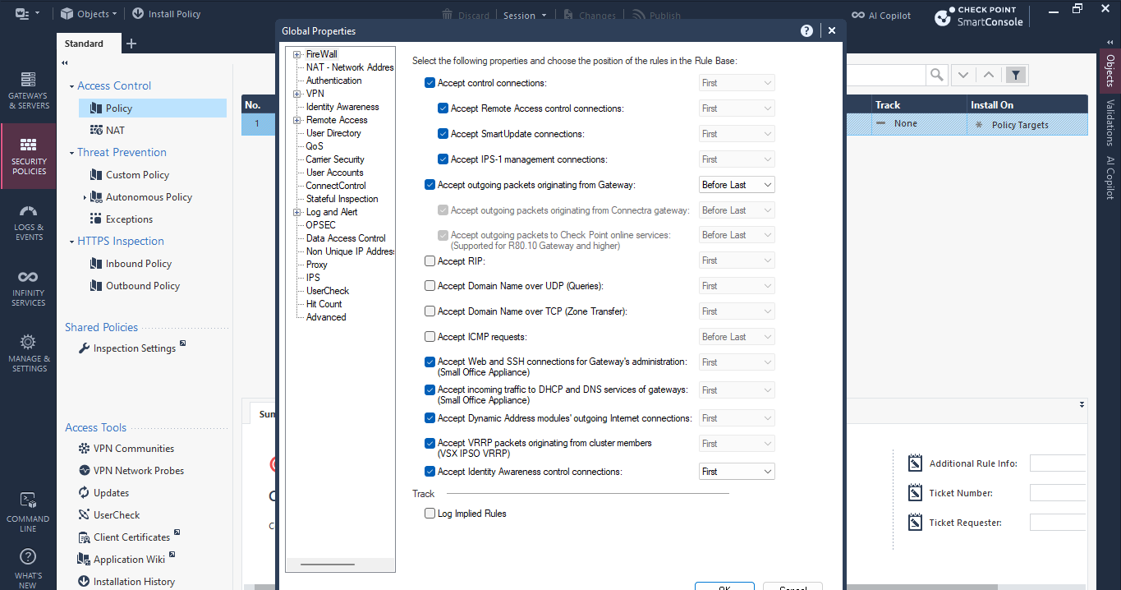

Manage policies and layers
Policies: Standard
Layers: Access control, Threat Prevention & HTTPS Inspection
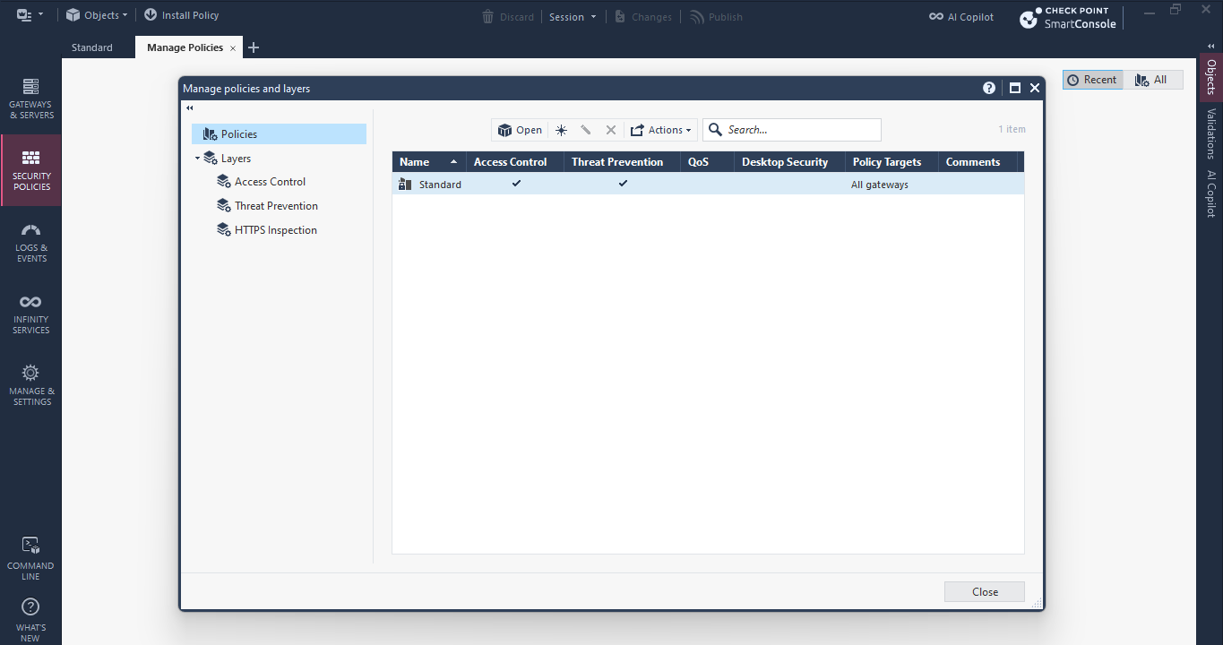

Task 2: Build the Access Control rulebase

Task 3: Organise the rulebase with sections
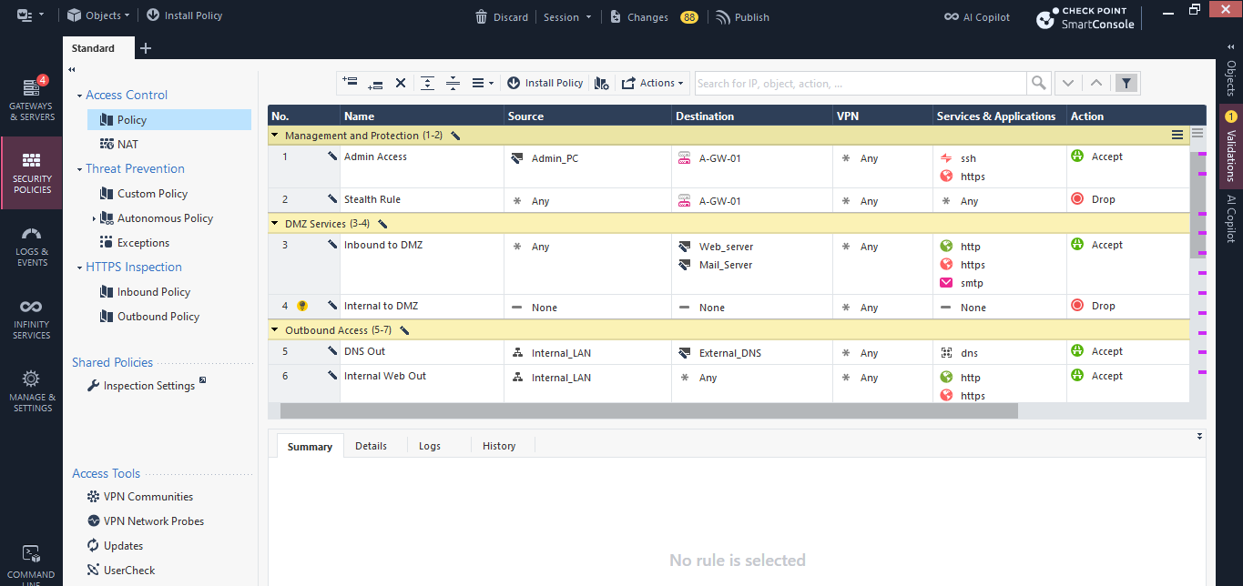
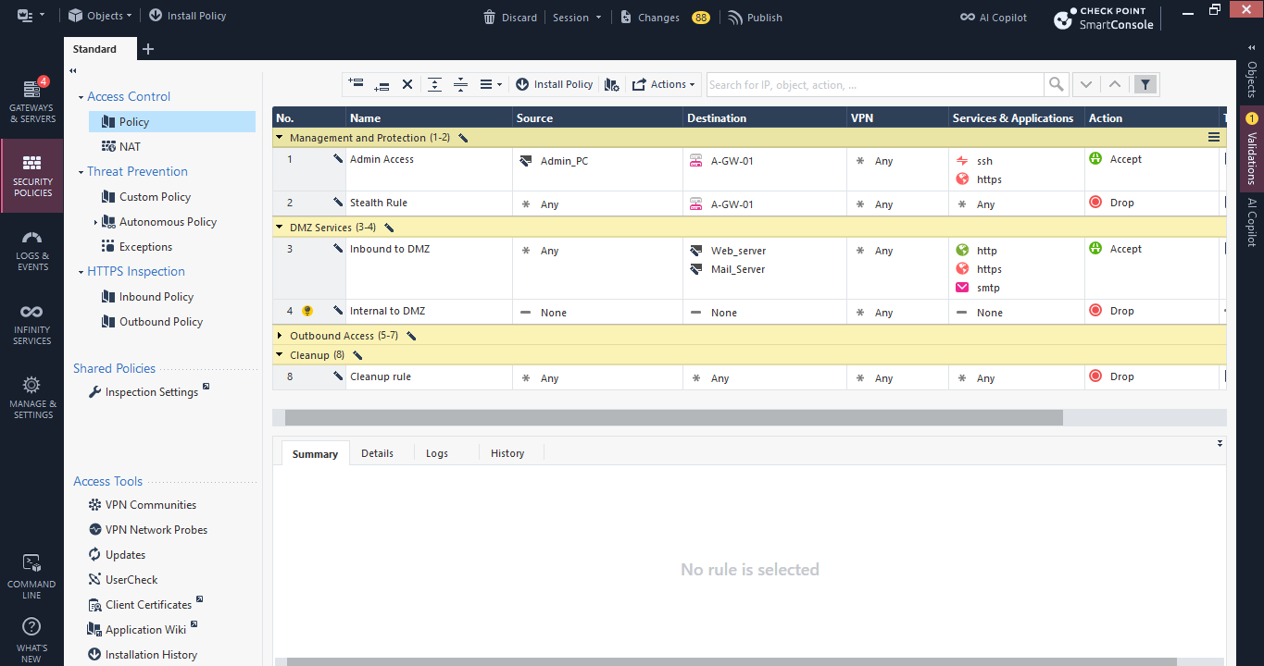

Sections do not affect rule enforcement order and they are not sent or processed by the Security Gateway.

Task 4: Configure Hide NAT
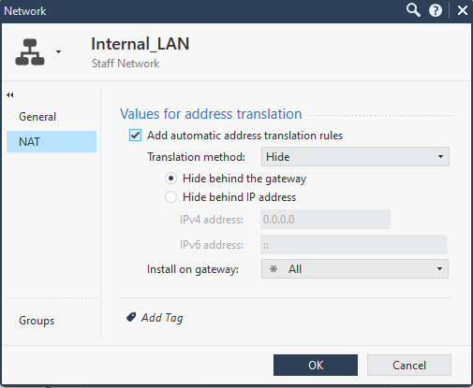
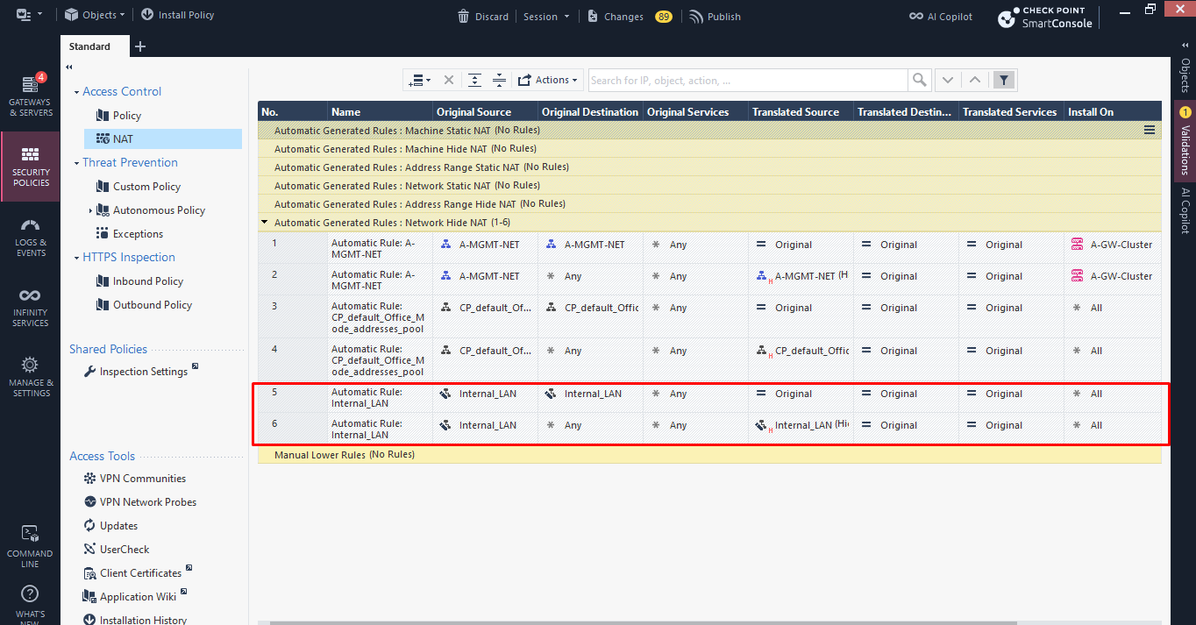

1. Automatic NAT vs. Manual NAT
- Automatic NAT rules are created automatically when NAT is configured in a network object's properties.
- Manual NAT can be created by administrators for specific NAT rule needs, such as port forwarding.

2. Many-to-One Translation (Hide NAT)
- Allows multiple devices on a private network to share one public IP address when accessing the internet. This saves public IP addresses and hides internal IPs.

3. Gateway Handling of Source Ports
- The gateway changes both the source IP and port to avoid conflicts between devices. It records the changes and uses them to forward replies to the correct internal device.

Task 5: Rule order experiment and Installation History

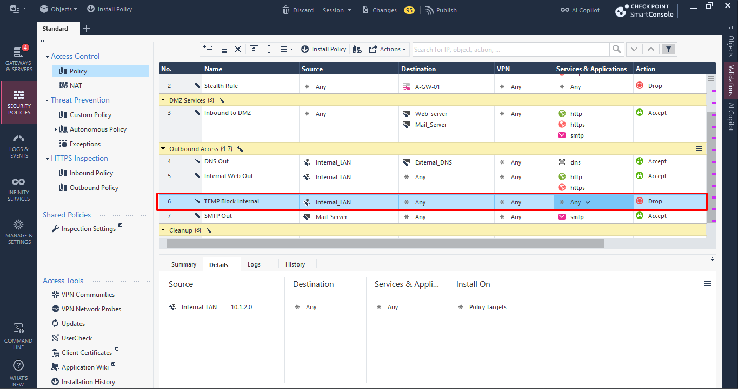

Part B: Theory Questions

Section B1:
Q1. Where is a Security Policy created, stored, and enforced?
B. Created in SmartConsole, stored on the Security Management Server, enforced by Security Gateways
Q2. Which control model does the Check Point Access Control firewall policy use?
A. Positive Control Model (whitelist)
Q3. Where should the Stealth rule be placed?
C. As early as possible, typically immediately after the Management rules
Q4. Which statement about rulebase sections is correct?
D. Sections are visual divisions only and do not affect enforcement order
Q5. What type of translation does Hide NAT perform?
B. Many-to-one

Section B2:

Q6. Distinguish between Explicit rules and implied rules. State where implied rules are configured and where they can be placed. What is the Implicit Cleanup Action?
Answer:
- Explicit Rules: Manually created by administrators in the rulebase.
- Implied Rules: Automatically generated and configured in Global Properties. They can be placed first, last, or before the last explicit rule.
- Implicit Cleanup Action: Determines how unmatched traffic is handled by default (Accept or Drop).
Q7. Explain why rule order matters in a rulebase. Give one example from your own rulebase.
Answer: Rules are processed from top to bottom. Once traffic matches a rule, its action is applied, and no further rules are checked. A general Any/Any Accept rule placed above a specific DNS or Stealth rule can bypass security restrictions.
Q8. Explain the difference between saving and publishing changes in SmartConsole. What happens to unpublished changes when you install a policy, and why do many organisations publish only during a change window?
Answer:
- Saving: Keeps changes in a private administrator session.
- Publishing: Commits changes to the shared management database for other administrators.
- Unpublished changes are not installed when deploying a policy. Organisations publish during approved change windows to avoid unexpected disruptions.
Q9. Compare Global Properties with Policy Packages. Give one example of what each controls and say how you open each in SmartConsole.
Answer:
- Global Properties: Controls system-wide settings such as Implied Rules and NAT defaults. Access via Applications Menu → Global Properties.
- Policy Packages: Contains security policies such as Access Control and Threat Prevention. Access via Applications Menu → Manage Policies and Layers.
Q10. Name the four predefined Security Zones. State two rules about assigning gateway interfaces to zones, and one benefit of using zone-based rules.
Answer:
- Four Zones: InternalZone, ExternalZone, DMZZone, and WirelessZone.
- Rules:
  - Each gateway interface can belong to only one zone.
  - Multiple interfaces can share the same zone.
- Benefit: Simplifies rule management by allowing policies to target entire security zones instead of individual interfaces.

Section B3: Scenario questions (10 marks, 5 marks each)
Q11. A new administrator inserts a rule with Source Any, Destination Any, Services Any and Action Accept above the Stealth rule. Describe two security problems this causes, explain how to correct it, and name the type of rule that is allowed to sit above the Stealth rule and why.
Answer:
- Security Problems:
  - Exposes the gateway by allowing unauthorised traffic to reach it, bypassing the Stealth rule.
  - Allows all traffic, bypassing other security rules.
- Correction: Remove the rule or move it below specific security rules.
- Allowed Rule Above Stealth: Management Rules (SSH, HTTPS, SNMP), which permit authorised administrators to access the gateway.
Q12. After Hide NAT is configured for Internal_LAN, staff report they cannot reach the Internet.
- State two benefits of NAT.
- Security: Hides internal private IP addresses.
- IP Conservation: Allows multiple devices to share one public IP address.
- Describe three checks you would make to find the fault, and explain why each one matters.
- Access Control Rules: Confirm that outbound traffic from Internal_LAN to ExternalZone is allowed.
- Hide NAT Configuration: Ensure Hide NAT is enabled on Internal_LAN and installed on the correct gateway.
- Gateway Routing: Verify the default route, interface topology, and Internet connectivity.

